this is the simple procedure to update sirepo locally and merge with Radiasoft:

***1, the development of sirepo is done locally, that means using vagrant to do the development:***

cmd

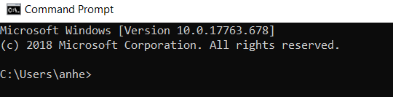

cd junk2

vagrant up

vagrant ssh

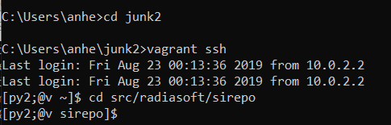

***2, check the git status***

If the latest version is my development, then maybe I shouldn’t do my new development for this stop. I need start my development at radiasoft’s new version.

[git discard all changes and pull from upstream](https://stackoverflow.com/questions/13781388/git-discard-all-changes-and-pull-from-upstream)

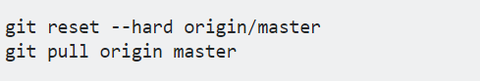

***3, and then I do my development. When it’s done, please follow the following to the updates to my******github: ahebnl.***

**[py2;@v sirepo]$ git remote -v**

ahefork http://github.com/ahebnl/sirepo.git (fetch)

ahefork http://github.com/ahebnl/sirepo.git (push)

origin https://github.com/radiasoft/sirepo.git (fetch)

origin https://github.com/radiasoft/sirepo.git (push)

**[py2;@v sirepo]$ git fetch ahefork**

warning: redirecting to https://github.com/ahebnl/sirepo.git/

remote: Enumerating objects: 18, done.

remote: Counting objects: 100% (18/18), done.

remote: Total 22 (delta 18), reused 18 (delta 18), pack-reused 4

Unpacking objects: 100% (22/22), done.

**[py2;@v sirepo]$ git merge ahefork/master**

Already up-to-date!

Merge made by the 'recursive' strategy.

**[py2;@v sirepo]$ git push ahefork master**

Username for 'https://github.com': ahebnl

Password for 'https://ahebnl@github.com':

warning: redirecting to https://github.com/ahebnl/sirepo.git/

Counting objects: 449, done.

Delta compression using up to 4 threads.

Compressing objects: 100% (119/119), done.

Writing objects: 100% (449/449), 283.90 KiB | 21.84 MiB/s, done.

Total 449 (delta 380), reused 394 (delta 330)

remote: Resolving deltas: 100% (380/380), completed with 87 local objects.

To http://github.com/ahebnl/sirepo.git

58dd1d5c..9fa9a1f9 master -> master

4, make the new updates available in our test server (apcpu-006) <https://expdev-test.nsls2.bnl.gov/>

Following Mrakitin’s repository: <https://github.com/mrakitin/sirepo-dev-config>

On apcpu-006

4.1 check and stop the server:

sudo systemctl status sirepo@rabbitmq sirepo@celery sirepo@uwsgi sirepo@nginx_proxy sirepo@flower

sudo systemctl stop sirepo@flower sirepo@nginx_proxy sirepo@uwsgi sirepo@celery sirepo@rabbitmq

4.2 update the sirepo version

sudo su – 

cd /home/expdev/sirepo

git pull



4.3 start the server

sudo systemctl start sirepo@rabbitmq sirepo@celery sirepo@uwsgi sirepo@nginx_proxy sirepo@flower